POONCH DISTRIT SCHOOLS DATA

1.Christ School Poonch
- Affiliation:Affiliated with the Jammu and Kashmir Board of School Education (JKBOSE).
- Management:Managed by the Carmelites of Mary Immaculate (CMI) Congregation.
- Founding:Founded by the CMI fathers from Kerala in 1990.
- Location:Located in Poonch, a historical city.
- Vision:To foster intellectually competent, just, and men and women of character.
- Approach:Adopts a unique and creative approach to education.
Facilities & Infrastructure
- Campus:Includes majestic buildings, quality classrooms, green campus, and playgrounds.
- Smart Classrooms:Features smart classrooms for interactive learning.
IMAGE : https://share.google/images/zXWvjxmtMQQ8VPnw7
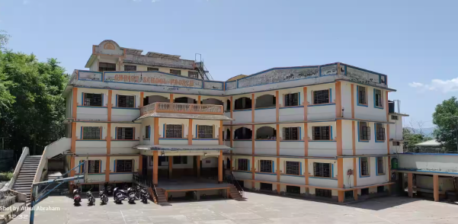

2.JAWAHAR NAVODAYA VIDYALAYA(JNV)
- Purpose:To provide quality, free, and residential education to talented children predominantly from rural areas.
- Curriculum:Aligned with the Central Board of Secondary Education (CBSE).
- Residential Facilities:Full boarding facilities, including hostels and free provision of uniforms, textbooks, stationery, and daily personal items.
Locations & Contact
- JNV Akhnoor (Jammu-II):
  - Address: Jawahar Navodaya Vidyalaya, Nardi Bala, Akhnoor, District Jammu II, Jammu & Kashmir, PIN- 181201.
  - Establishment Year: 2017.
- JNV Gharota (Jammu-I):
  - Address: Jawahar Navodaya Vidyalaya, GHAROTA District Jammu-I, Pin-181122.
  - Contact: +91-0191-2624919/2624929.
Admission
- Entrance Exam:Candidates are selected through the Navodaya Vidyalaya Selection Test (NVST) for Class 6 admissions.
- Eligibility:Students must meet age and academic criteria.
- Application Process:Applications are invited annually, with details available on the official navodaya.gov.in website.
Facilities and Programs
- Holistic Development:Focus on intellectual, cultural, and physical development.
- Competitive Exam Prep:Students are prepared for competitive examinations for higher education.
- Support:Scholarships are available for economically weaker students.
IMAGE : https://share.google/images/PNUDgIQkk5xonCery
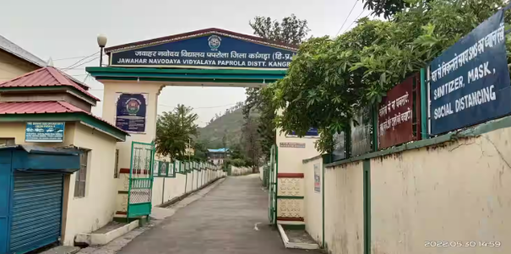

3. HIGHER SECONDARY SCHOOL (HSS) BOYS POONCH
- Location:Ward No 3, District Poonch, Jammu and Kashmir
- Type:Boys' school
- Classes:9 to 12
- Medium of Instruction:English
- Management:Department of Education
- Total Teachers:35
- Establishment Year:1935
- School Type:Urban
- Residential: NO
- IMAGE : https://share.google/images/oG7AbtI1FSRe28UB9